Contents

Approach for Collecting Requirements: - 2

Requirement Traceability Matrix 2

Scope Statement (Version I) 3

Work Breakdown Structure for Recreation and Wellness Intranet 5

Gantt chart 6

Scope verification and change control 9

Scope verification 9

Change control 9

5_1) Document y our approach for collecting requirements for the project described in the Running Case section. Include at least five requirements in a requirements traceability matrix.

# Approach for Collecting Requirements: -

1. Start by having the brief discussion with the team and some expects to get the ideas of the project requirements.
2. After the ideas get generated we must decide the team having the best ideas and once the idea get selected we must to start working on the requirements.
3. We will group interview and discussions the employee, experts and the project team whose idea been selected for the clear or better perspective on the requirements of the project.
4. Expects then selects the programs and activities where they can interview the employees and find the most suitable persons to work on the project or the persons who willingly want to be the part of the project.
5. The project team should review the project since it also has some high-level requirements for the project and may refer to other documents for requirements.
6. Also after reviewing the documents a review needed with the stake holders to ensure about the stakeholders have same requirements.

# Requirement Traceability Matrix

|  |  |  |  |  |
| --- | --- | --- | --- | --- |
| **Requirement No.** | **Name** | **Category** | **Source** | **Status** |
| Req001 | Tracking for employee Data Software | Software | Project charter | Developing application for the Tracking of the Employee |
| Req002 | Laptop for Employee | Hardware | Project charter | Complete. Laptops ordered meet requirement by having 16 GB of memory. |
| Req003 | Incentives | Financial | Project charter | Discussion on Incentives that will motivate employees |
| Req004 | Not to Cross budget of $200,000 | Financial | Project charter | In Budget |
| Req005 | Schedule goal is six months | Schedule | Project charter | Currently On time |

5_2) Develop a first version of a project scope statement for the project. Use the template provided on the companion Web site for this text and the example in Chapter 3 as guides. Be

as specific as possible in describing product characteristics and requirements, as well as

all the project’s deliverables. Be sure to include testing and training as part of the project

scope.

# Scope Statement (Version I)

**Project Title: Recreation and Wellness Intranet Project**

**Start Date 02/14/2017 Prepared by: Partha S Satpathy**

|  |
| --- |
| **Project Description** |
| Manage Your Health, Inc. (MYH) is a Fortune 500 company that provides a variety of healthcare services across the globe. Recently MYH updated its strategic plan, and key goals which include reducing internal costs. The budget for the project is $200,000. An additional $150,000 per year will be required for operational expenses after the project has been completed. Also for next three years and cost about $800,000 each year for development and maintenance. |

**Product Requirements and Characteristics:**

1. Allow employees to register for company approved recreational programs.
2. Track Employee involvement in the recreational programs they have registered.
3. Offer incentive to the employees who have registered for the program.
4. The application must be available for the employees to track the performance.
5. The project must be within Budget.
6. The project must be on the time.

**Summary of Project Deliverables:**

|  |
| --- |
| **Project management-related deliverables:** |
| Business case, charter, team contract, scope statement, WBS, schedule, cost baseline, status reports, final project report, lessons-learned report. |

|  |
| --- |
| **Product-related deliverables:** |
| Survey current employees for the requirement recreational programs |
| Database: To track employee data on involvement for analysis. |
| Incentives: Determine incentives that will motivate employees to join and complete programs. |
| Testing: Testing of the application and make sure it is user friendly. |
| Promotion: To motivate employees and to announce the benefits for the employees who joins the recreational activity. |

**Project Success Criteria:**

All the specification must meet and to be thoroughly tested, and the project must be completed on time within the specified Budget. The project goal is to complete within six months and not more than the specified Budget. To meet its goal employees must participate in the program to gain the benefits from the project.

5_3) Develop a work breakdown structure for the project. Break down the work to Level 3 or

Level 4, as appropriate. Use the template on the companion Web site and samples in this

text as guides. Print the WBS in list form. Be sure the WBS is based on the project charter

(created for the Chapter 4 Running Case), the project scope statement created in Task 2,

and other relevant information.

# Work Breakdown Structure for Recreation and Wellness Intranet

**Start Date 02/14/2017 Prepared by: Partha S Satpathy**

1. **Initiating** 
   1. **Identification of Key Stake holders**
   2. **Prepare Project Charter**
   3. **Initiate Project Meeting with Stake Holders and Responsible Persons**
2. **Planning** 
   1. **Responsible Team Planning** 
      1. **Team Contract**
      2. **Team Concerns and Questions**
   2. **Identify Discuss projects**
   3. **Prioritize tasks**
   4. **Prepare Scope Statement**
   5. **Prepare WBS**
   6. **Create Draft Grant Chart**
   7. **Prepare Schedule and cost baseline**
      1. **Project Cost Model Estimate**
      2. **Project Cost Model Baseline**
3. **Executing** 
   1. **Collect Requirements** 
      1. **Requirement Question**
   2. **Application Design**
   3. **Application Development**
   4. **Application Testing**
   5. **Application UAT (User acceptance Testing)**
   6. **Application Roll out**
   7. **Application Training**
4. **Monitoring and Controlling** 
   1. **Monitoring Report**
5. **Closing** 
   1. **Lessons learned**
   2. **Final Report**
   3. **Final Presentation**

5_4) Use the WBS you developed in Task 3 to begin creating a Gantt chart using your choice

of software. Do not enter any durations or dependencies. Print the resulting Gantt chart on

one page, and be sure to display the entire Task Name column.

# Gantt chart

|  |  |  |  |
| --- | --- | --- | --- |
| Task Name | Duration | Start | Finish |
| **1 Initiating** | **5 days** | **Tue 2/14/17** | **Sat 2/18/17** |
| **1.1 Identification of Key Stake holders** | 1 day | Tue 2/14/17 | Tue 2/14/17 |
| **1.2 Prepare Project Charter** | 2 days | Wed 2/15/17 | Thu 2/16/17 |
| **1.3 Initiate Project Meeting with Stake Holders and Responsible Persons** | 1 day | Fri 2/17/17 | Fri 2/17/17 |
| **2 Planning** | **14 days** | **Sun 2/19/17** | **Wed 3/8/17** |
| **2.1 Responsible Team Planning** | 2 days | Sun 2/19/17 | Mon 2/20/17 |
| **2.1.1 Team Contract** | 1 day | Sun 2/19/17 | Sun 2/19/17 |
| **2.1.2 Team Concerns and Questions** | 1 day | Mon 2/20/17 | Mon 2/20/17 |
| **2.2 Identify Discuss projects** | 2 days | Tue 2/21/17 | Wed 2/22/17 |
| **2.3 Prioritize tasks** | 1 day | Thu 2/23/17 | Thu 2/23/17 |
| **2.4 Prepare Scope Statement** | 2 days | Fri 2/24/17 | Sat 2/25/17 |
| **2.5 Prepare WBS** | 1 day | Sun 2/26/17 | Sun 2/26/17 |
| **2.6 Create Draft Grant Chart** | 1 day | Tue 2/28/17 | Tue 2/28/17 |
| **2.7 Prepare Schedule and cost baseline** | **3 days** | **Wed 3/1/17** | **Fri 3/3/17** |
| **2.7.1 Determine Cost Model Estimate** | 1 day | Wed 3/1/17 | Wed 3/1/17 |
| **2.7.2 Determine Cost Model Baseline** | 2 days | Thu 3/2/17 | Fri 3/3/17 |
| **2.8 Identify Quality Requirements** | 4 days | Fri 3/3/17 | Wed 3/8/17 |
| **3 Executing** | **94 days** | **Thu 3/9/17** | **Tue 7/18/17** |
| **3.1 Prepare List of Programs** | **9 days** | **Thu 3/9/17** | **Tue 3/21/17** |
| **3.1.1 Document User Stories** | 5 days | Wed 3/15/17 | Tue 3/21/17 |
| **3.2 Application Design** | 24 days | Tue 3/21/17 | Fri 4/21/17 |
| **3.3 Application Development** | **37 days** | **Sat 4/22/17** | **Sat 6/10/17** |
| **3.3.1 Database Development** | 11 days | Sat 4/22/17 | Fri 5/5/17 |
| **3.3.2 Webpage Development** | 13 days | Fri 5/5/17 | Tue 5/23/17 |
| **3.3.3 Web services Development** | 14 days | Wed 5/24/17 | Sat 6/10/17 |
| **3.4 Application Testing** | 12 days | Sun 6/11/17 | Sat 6/24/17 |
| **3.5 Application UAT (User acceptance Testing)** | 6 days | Sun 6/25/17 | Fri 6/30/17 |
| **3.6 Application Roll out** | 1 day | Sat 7/1/17 | Sat 7/1/17 |
| **3.7 Application Training** | 13 days | Sun 7/2/17 | Tue 7/18/17 |
| **4 Monitoring and Controlling** | **111 days** | **Tue 2/14/17** | **Tue 7/18/17** |
| **4.1 Monitoring Report** | 1 day | Sun 7/19/17 | Sun 7/19/17 |
| **5 Closing** | **8 days** | **Mon 7/19/17** | **Wed 7/26/17** |
| **5.1 Lessons learned** | 3 days | Mon 7/19/17 | Tue 7/21/17 |
| **5.2 Final Report** | 3 days | Wed 7/22/17 | Thu 7/24/17 |
| **5.3 Final Presentation** | 2 days | Fri 7/25/17 | Sat 7/26/17 |

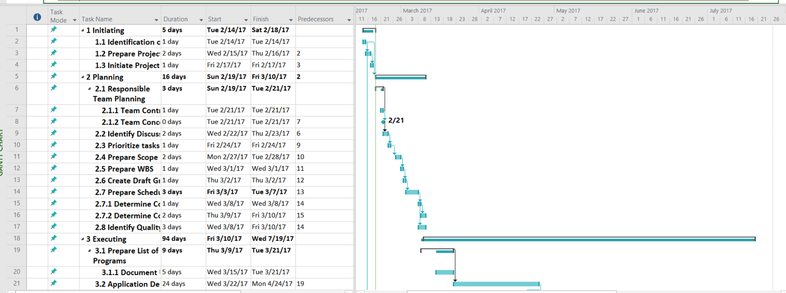

5_5) Develop a strategy for scope validation and change control for this project. Write a short

paper summarizing key points of the strategy.

# Scope verification and change control

## Scope verification

Project manager will verify all the progress will be per the original scope and the Scope defined in the WBS and scope statement. Once the Project Manager verifies all the requirement are met then the project manager and the sponsor will meet for the formal deliverable. During the meeting project manager, will present the deliverable product to the Project sponsor. The project team will ensure that they perform only the work described in the WBS and generate the defined deliverables for each WBS element.

## Change control

If the change to the project scope is required, then the Changes will be occurring through the Change Control process. Any project team member or sponsor can request changes to the project scope. All change requests must be submitted to the Project Manager in the form of a project change request document. The project manager will review the Changes to the scope of the Project. Project manager can either approve or deny the changes. If project Changes gets approved, then the changes will be submitted to Change Control Board. This is just to ensure that not just any changes can be made to the project it must be in scope of the project.